



Implementation of End-to-End Dictionary Operations
LAB MANUAL

Disclaimer: The content is curated from online/offline resources and used for educational purpose only
Implementation of End-to-End Dictionary Operations
Objective:
- Learn how to create, access, and modify dictionary elements.
- Use methods to add and remove key-value pairs from dictionaries.
- Check if a key exists in a dictionary using in and get() methods.
- Loop through the keys, values, and items of a dictionary.
- Merge two or more dictionaries into one.
- Generate dictionaries based on specified conditions using comprehension.
- Understand how to work with dictionaries that have other dictionaries as values.
- Learn how to clear a dictionary and make copies of dictionaries.
Problem Statement:
- In this problem , to implement a Python program that demonstrates various dictionary operations, such as adding, updating, and removing key-value pairs. Additionally, the program should include operations for checking if a key exists, iterating through the dictionary, merging dictionaries, and using dictionary comprehension. You should also explore handling nested dictionaries and demonstrate how to copy and clear dictionaries.
Equipment Required:
- Install VS Code - https://code.visualstudio.com/download
- Download Python Installer File - https://www.python.org/downloads/
Prerequisites:
- Basic Computer Skills - Anyone starting to learn computer programming needs basic computer skills.
- Basics of control statements

Procedure:

Task 1: Implementation of Creating a Dictionary
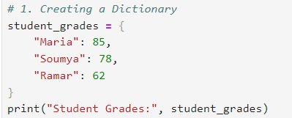
Output:
Task 2: Implementation of Accessing Dictionary Values
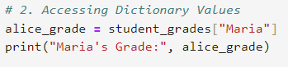
Output:
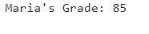
Task 3: Implementation of Adding a New Key-Value Pair
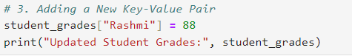
Output:
Task 4: Implementation of Removing a Key-Value Pair
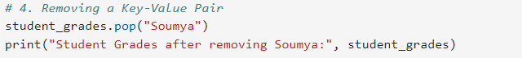
Output:
Task 5: Implementation of Checking Key Membership
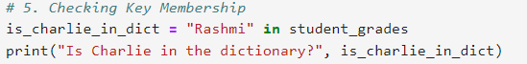
Output:
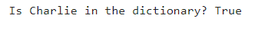
Task 6: Implementation of Iterating Over a Dictionary (Keys and Values)
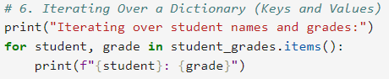
Output:
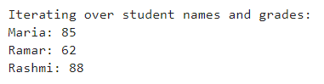
Task 7: Implementation of Using the get() Method
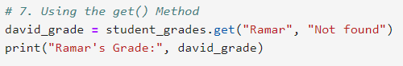
Output:
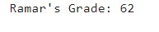
Task 8: Implementation of Merging Dictionaries
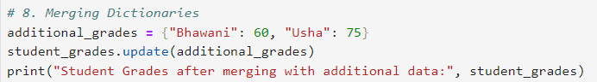
Output:
Task 9: Implementation of Dictionary Comprehension
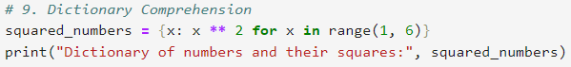
Output:
Task 10: Implementation of Handling Nested Dictionaries
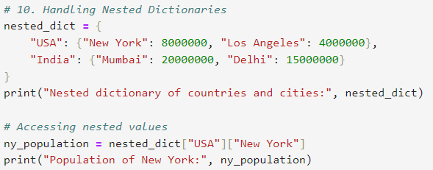
Output:

Task 11: Implementation of Clearing and Copying Dictionaries
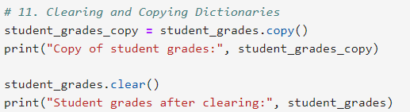
Output:

